Murcielago Farms
B/R Ruby 7130 Reg: AAA 15717587

Owned with 44 Farms

Paramount Ambush 2172 #10239760 [AMF-CAF-NHF]
Rockn D Ambush 1531 #12396365 [AMF-CAF-NHF]
MS Blackcap Band of R D 1301 11960183
B/R Ambush 28 +14188956 [AMF-CAF-NHF]
N Bar Emulation EXT #10776479 [AMF-CAF-NHF]
B/R Ruby of Tiffany 8250 +13355447 [AMF-NHF]
B/R Ruby of Tiffany 5113 12327822

GAR Traveler 1489 #11356596 [AMF-CAF]
B/R Destination 727 #12784697 [AMF-NHF]
B/R Ruby of Tiffany 5113 12327822
B/R Ruby 9114 13286162 [AMF]
B/R New Design 036 #11418151 [AMF-NHF]
B/R Ruby 521 12327769
B/R Ruby 7104 #10970263

#Pathfinder + Embryo Transplant

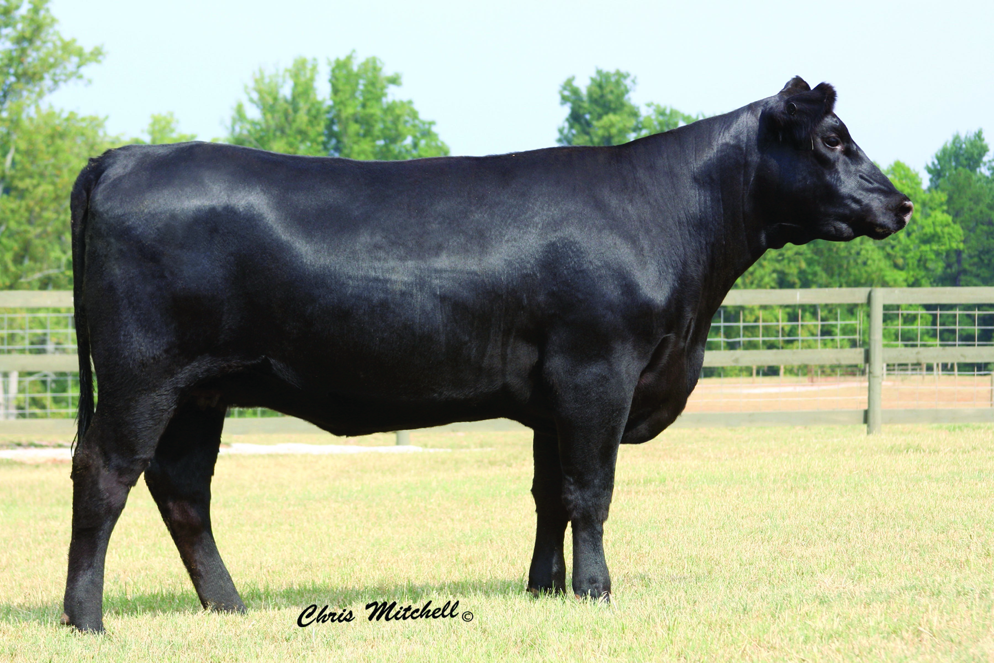

Production |  |  |  |  |  | Maternal
CED  Acc | BW  Acc | WW  Acc | YW  Acc | YH  Acc | SC  Acc | CEM  Acc | Milk  Acc | MkH  MkD | MW  Acc | MH  Acc | $EN
+3  .30 | +3.8  .38 | +54  .29 | +98  .28 | I+.8  .05 | I+.26  .05 | +6  .21 | +25  .24 |  |  |  | -6.46

Carcass
CW  Acc | Marb  Acc | RE  Acc | Fat  Acc | Carc Grp  Carc Pg | Usnd Grp  Usnd Pg
+25  .19 | +.83  .22 | +.46  .29 | -.023  .22 |  | 3  4

$Values
$W | $F | $G | $QG | $YG | $B
+23.78 | +35.66 | +41.08 | +31.94 | +9.14 | +71.95

