Murcielago Farms
Oak Hill Polly 8200 Reg: AAA +13277925
[AMF]

Band 234 of Ideal 3163 #8505294
QAS Traveler 23-4 #9250717 [AMF-CAF-NHF]
QAS Blackbird Eve 601 1 78851153
Traveler 124 G D A R #9995349
CSU Rito 4114 #8235606
Rachel Rito 813 G D A R 9251184
Rachel 966 G D A R #6294119

Rito 2100 G D A R #10132935
V D A R Rito 953 #11754914 [AMF]
Miss Wix 903 0f Mc Cumber 11286963
V D A R Polly 4027 +12117961
QAS Traveler 23-4 #9250717 [AMF-CAF-NHF]
V D A R Polly 215 11263750
V D A R Polly 31 10959918

#Pathfinder + Embryo Transplant

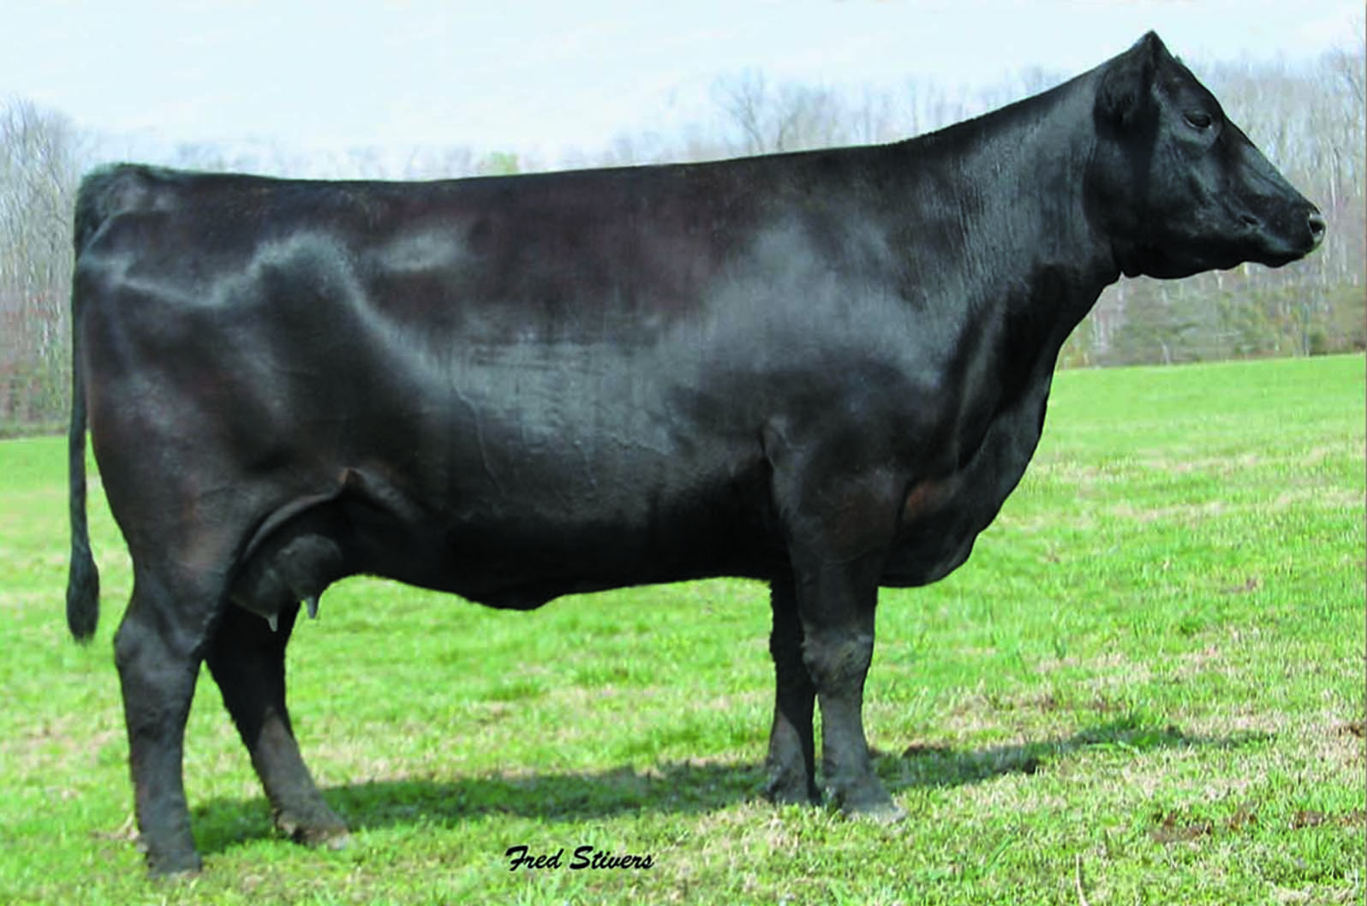

Production |  |  |  |  |  | Maternal
CED  Acc | BW  Acc | WW  Acc | YW  Acc | YH  Acc | SC  Acc | CEM  Acc | Milk  Acc | MkH  MkD | MW  Acc | MH  Acc | $EN
+3  .35 | +1.6  .54 | +37  .45 | +70  .34 | +.6  .36 | -.01  .39 | -1  .32 | +33  .44 | 16  18 | +21  .11 | +.4  .12 | -4.44

Carcass
CW  Acc | Marb  Acc | RE  Acc | Fat  Acc | Carc Grp  Carc Pg | Usnd Grp  Usnd Pg
-1  .24 | +.28  .29 | +.10  .36 | +.011  .29 |  | 25  40

$Values
$W | $F | $G | $QG | $YG | $B
+26.86 | +14.79 | +23.18 | +17.10 | +6.08 | +28.98

