Murcielago Farms
EXAR Evas 8358 Reg: AAA +16084348
[AMF-NHF]

V D A R New Trend 315 #11105489 [AMF-CAF-NHF]
B/R New Design 036 #11418151 [AMF-NHF]
B/R Blackcap Empress 76 10970296
GAR Predestined #13395344 [AMF-CAF-NHF]
N Bar Emulation EXT #10776479 [AMF-CAF-NHF]
GAR Ext 4206 #+12716727
GAR 6807 Traveler 1432 +11872350

Emulation N Bar 5522 #10095639
N Bar Emulation EXT #10776479 [AMF-CAF-NHF]
N Bar Primrose 2424 10474919
GAR Evas Ext 1525 +12548649 [AMF]
Tehama Bando 155 #9891499 [AMF-CAF-NHF]
GAR Bando 338 11117490
9J9 GAR 246 10895295

#Pathfinder + Embryo Transplant

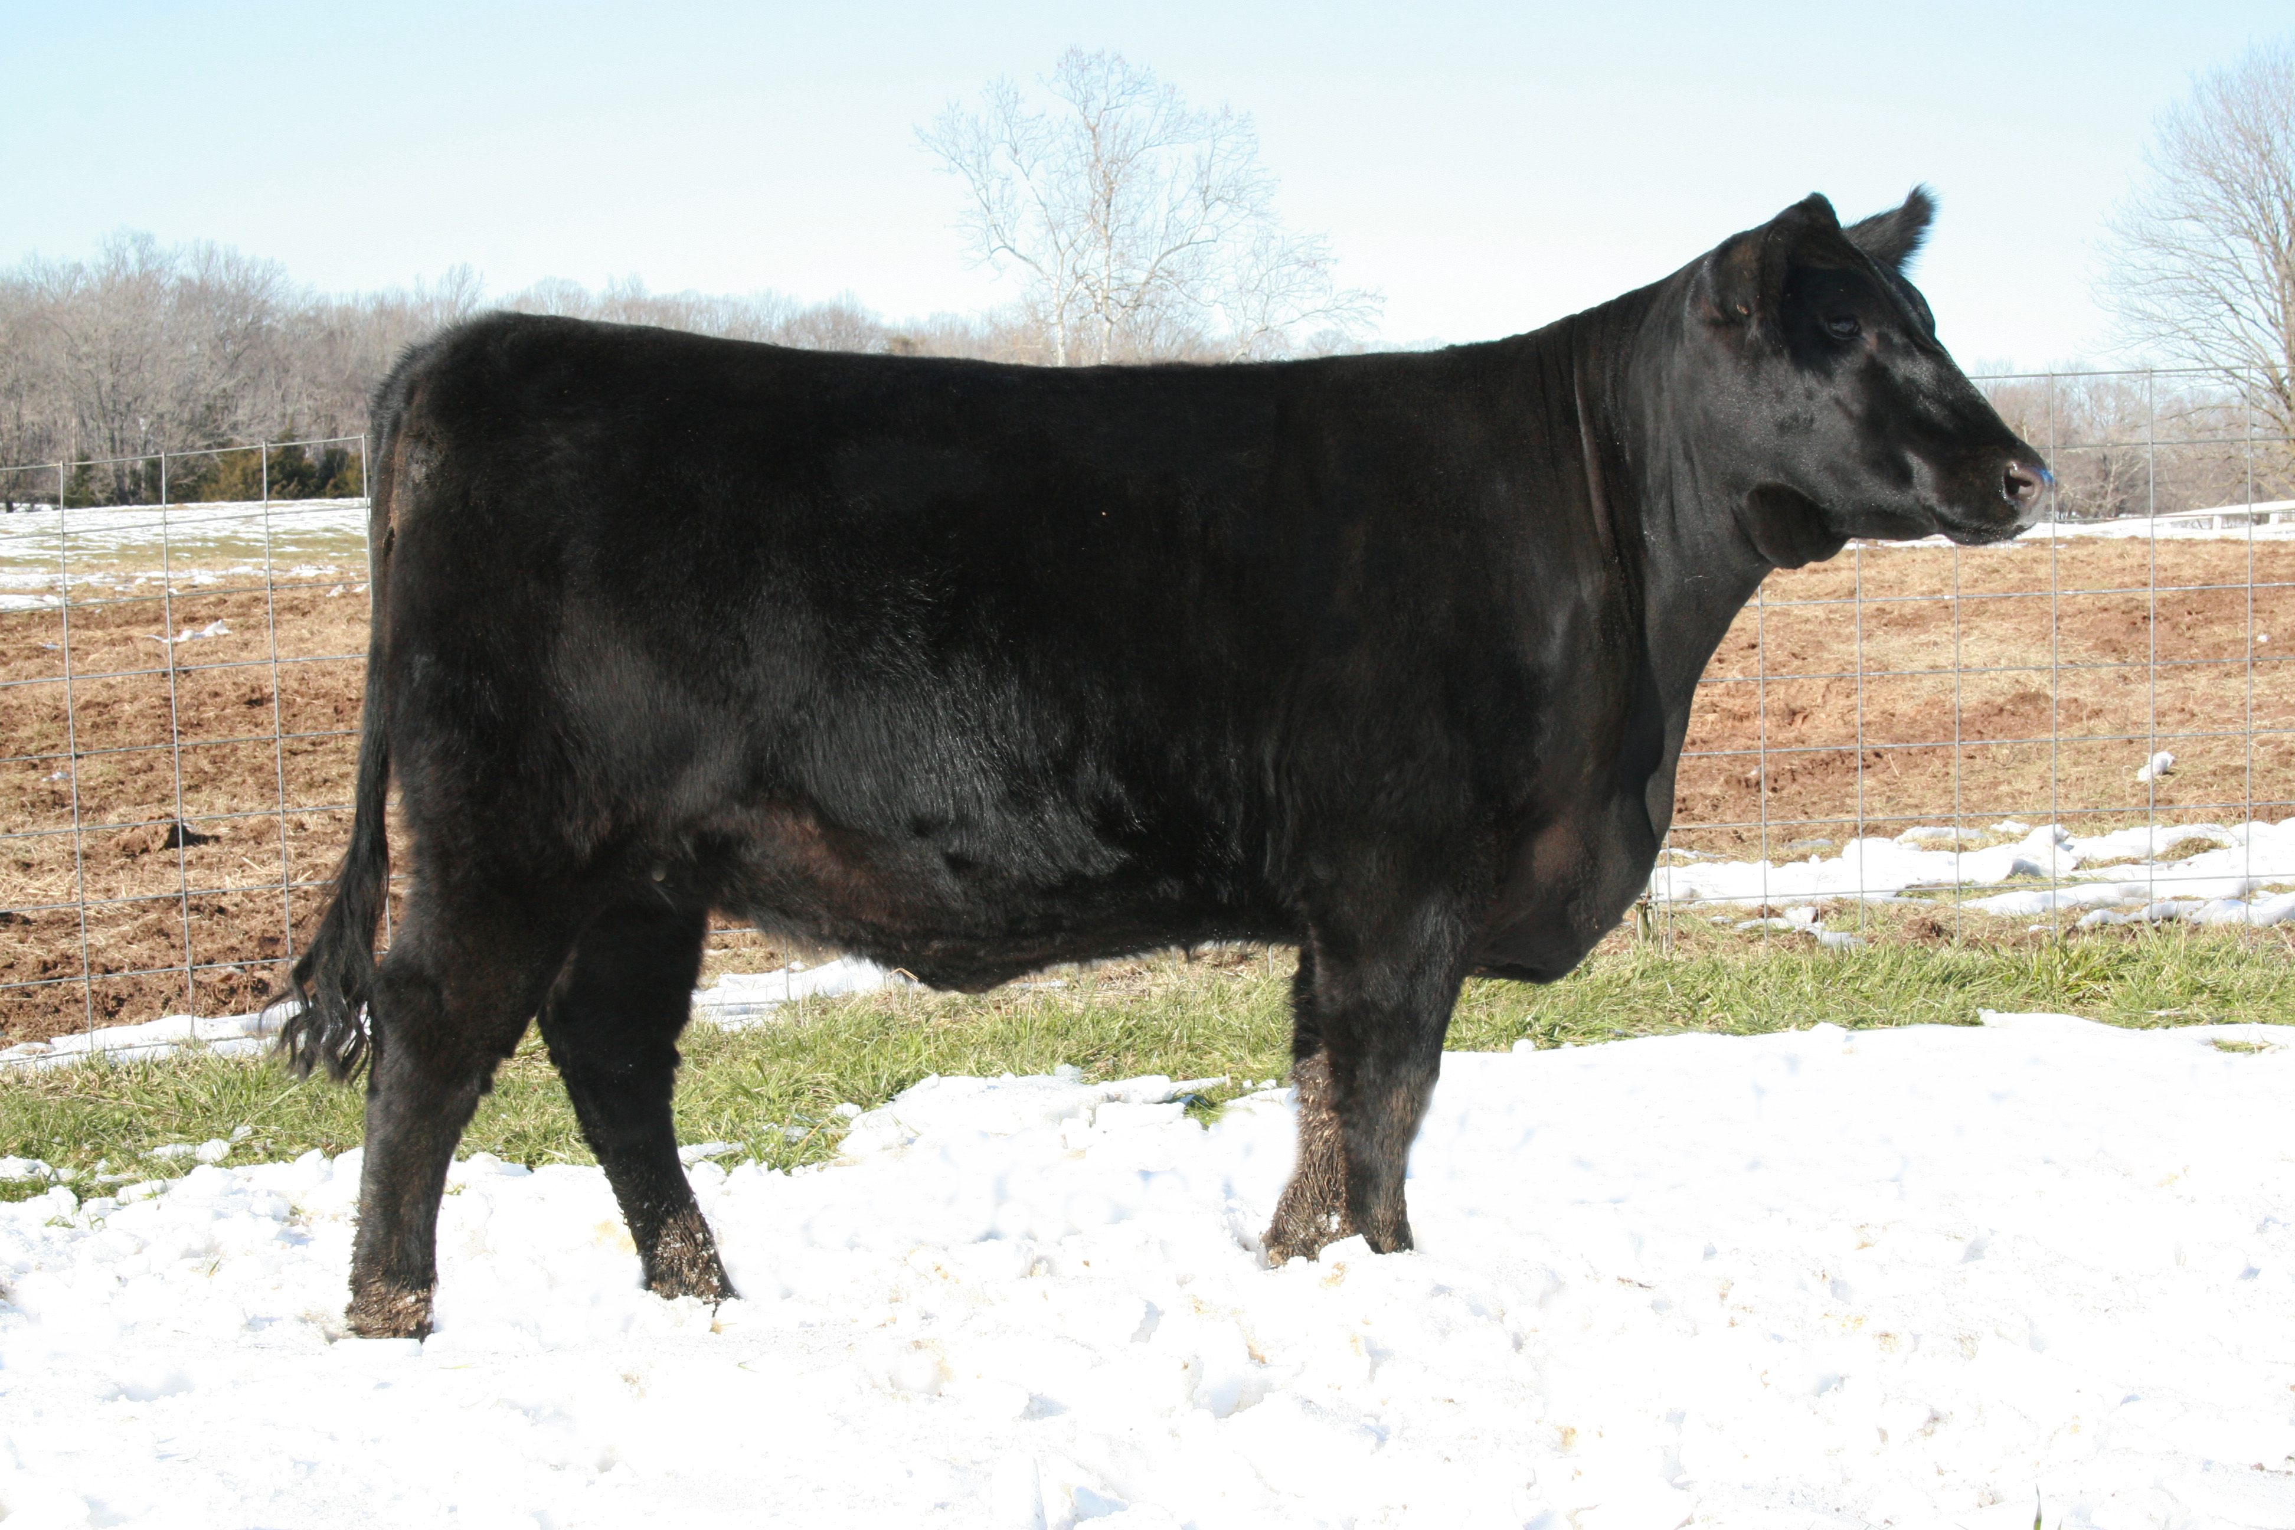

Production |  |  |  |  |  | Maternal
CED  Acc | BW  Acc | WW  Acc | YW  Acc | YH  Acc | SC  Acc | CEM  Acc | Milk  Acc | MkH  MkD | MW  Acc | MH  Acc | $EN
I+4  .05 | I+3.9  .05 | I+47  .05 | I+90  .05 | I+0  .05 | I+.17  .05 | I+8  .05 | I+24  .05 |  | I+6  .05 | I+.2  .05 | +4.04

Carcass
CW  Acc | Marb  Acc | RE  Acc | Fat  Acc | Carc Grp  Carc Pg | Usnd Grp  Usnd Pg
+21  .24 | +.63  .26 | +.39  .32 | +.048  .25

$Values
$W | $F | $G | $QG | $YG | $B
+28.06 | +30.32 | +29.00 | +27.98 | +1.02 | +56.47

