Murcielago Farms
SandPoint Lucy 9814 Reg: AAA +16603728

DHD Traveler 6807 #10858958 [AMF-NHF]
S S Traveler 6807 T510 #12502030 [AMF-CAF-NHF]
S S Miss Hi Spade A114 #11665432
S S Objective T510 0T26 13776378 [AMF-CAF-NHF]
S S Rito Rito R76 R011 11494687
S S Miss Rita R011 7R8 12958951 [AMF-NHF]
S S Miss Ultress U56 12490161

B/R New Design 036 #11418151 [AMF-NHF]
Bon View New Design 1407 #12783540 [AMF-CAF-NHF]
Bon View Pride 664 12139985
Basin Lucy 3059 +14401020 [AMF-NHF]
Basin Max 602C #11951654 [AMF-CAF-NHF]
Basin Lucy 178E 12326453
Basin Lucy 855A #11549687

#Pathfinder + Embryo Transplant

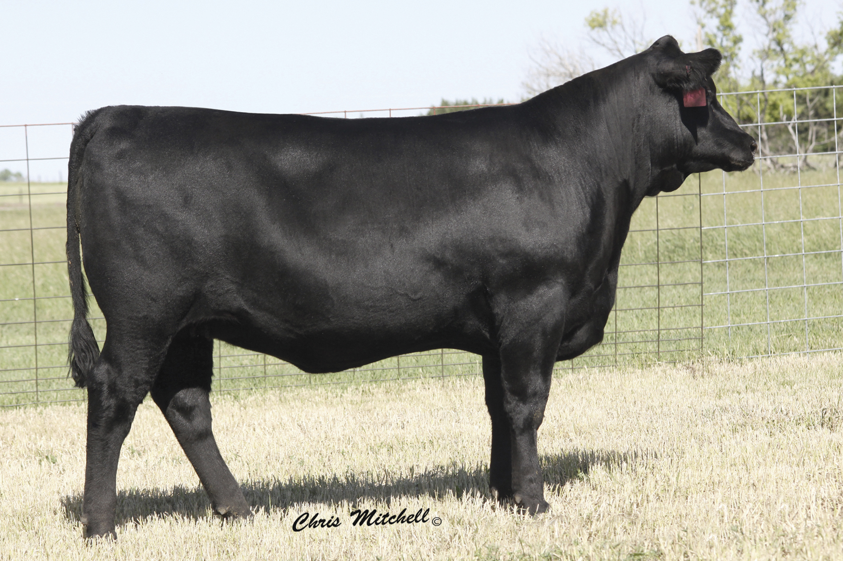

Production |  |  |  |  |  | Maternal
CED  Acc | BW  Acc | WW  Acc | YW  Acc | YH  Acc | SC  Acc | CEM  Acc | Milk  Acc | MkH  MkD | MW  Acc | MH  Acc | $EN
I+9  .05 | I+.5  .05 | I+66  .05 | I+119  .05 | I+.6  .05 | I+.35  .05 | I+8  .05 | I+36  .05 |  |  |  | -23.64

Carcass
CW  Acc | Marb  Acc | RE  Acc | Fat  Acc | Carc Grp  Carc Pg | Usnd Grp  Usnd Pg
+9  .25 | +.71  .27 | +.30  .32 | -.006  .26

$Values
$W | $F | $G | $QG | $YG | $B
+32.24 | +52.96 | +38.14 | +29.81 | +8.33 | +63.01

