Murcielago Farms
VT 1407 New Design Z38 Reg: AAA +14399856
[AMF]

Owned with Castle Hill Farm

VDAR New Trend 315 #11105489 [AMF-CAF-NHF]
B/R New Design 036 #11418151 [AMF-NHF]
B/R Blackcap Empress 76 10970296
Bon View New Design 1407 #12783540 [AMF-CAF-NHF]
GAR Sleep Easy 1009 #+11356568 [AMF-CAF-NHF] Bon View Pride 664 12139985
Bon View Pride 1551 #11557114

DHD Traveler 6807 #10858958 [AMF-NHF]
Plowman 1627 of Millbrae SAR #12194989 [AMF-CAF-NHF]
M B Joanie 8E8 1627 #11607227 [AMF]
GAR Plowman G240 +13641685 [AMF-NHF]
GAR Precision 1680 #11520398 [AMC-NHC]
GAR Precision 2536 12716656 [AMC-NHF]
GAR EXT 2104 +12356150

#Pathfinder + Embryo Transplant
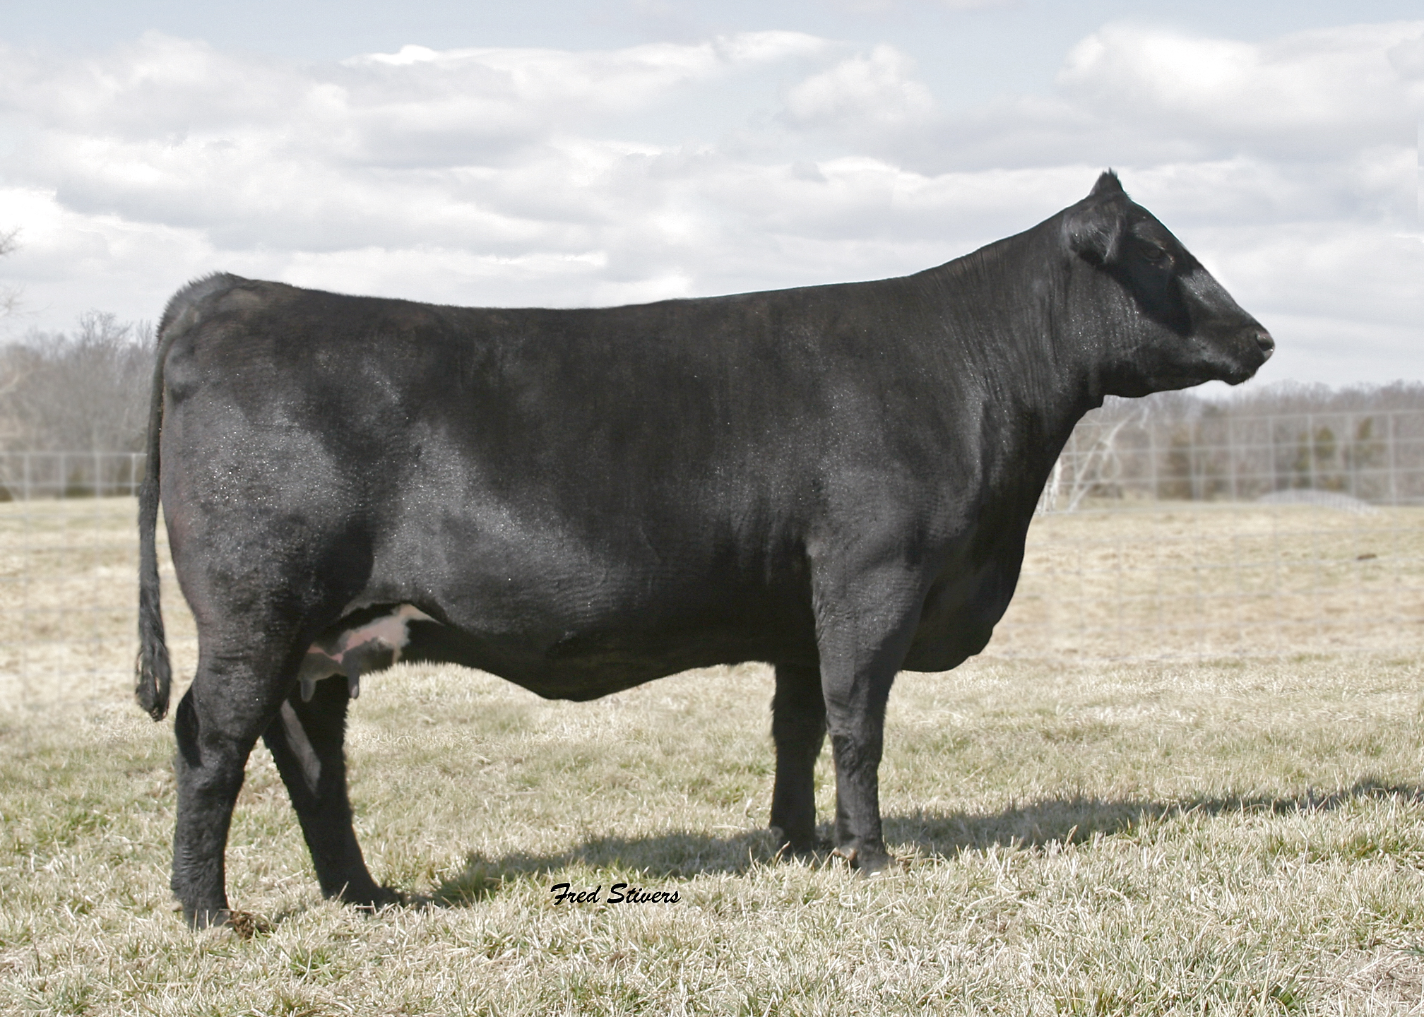

Production |  |  |  |  |  | Maternal
CED  Acc | BW  Acc | WW  Acc | YW  Acc | YH  Acc | SC  Acc | CEM  Acc | Milk  Acc | MkH  MkD | MW  Acc | MH  Acc | $EN
+10  .30 | +1.7  .53 | +48  .41 | +96  .32 | +.5  .67 | .42  .59 | +11  .30 | +15  .38 | 10  18 | I+19  .05 | I+.3  .05 | +5.06

Carcass
CW  Acc | Marb  Acc | RE  Acc | Fat  Acc | Carc Grp  Carc Pg | Usnd Grp  Usnd Pg
+11  .27 | +1.02  .34 | +.26  .41 | +.050  .33 |  | 42  99

$Values
$W | $F | $G | $QG | $YG | $B
+24.02 | +35.99 | +35.52 | +34.51 | +1.01 | +57.45

